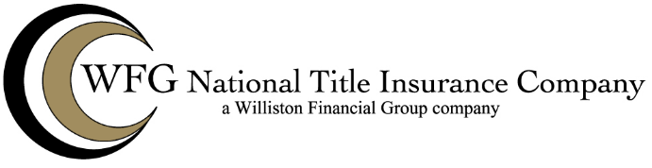

Severable Improvements

NM FORM 92

**NM FORM 92: SEVERABLE IMPROVEMENTS ENDORSEMENT**

**Attached to Policy No. __________   
Issued by**

**WFG NATIONAL TITLE INSURANCE COMPANY**

1. As used in this endorsement, "Severable Improvement" means property affixed to the Land on or after Date of Policy that by law does not constitute real property because:

a. of its character and manner of attachment to the Land; and

b. it can be severed from the Land without causing material damage to it or to the   
Land.

2. In the event of a loss by reason of a defect, lien, encumbrance, or other matter covered by this Policy (“Defect”), the calculation of the loss shall include (but not to the extent that these items of loss are included in the valuation of the Title determined pursuant to Section 8 of the Conditions or any other endorsement to the Policy):

a. the diminution in value of the Insured’s interest in any Severable Improvement   
resulting from the Defect, reduced by the salvage value of the Severable Improvement; and

b. the reasonable cost actually incurred by the Insured in connection with the   
removal or relocation of the Severable Improvement resulting from the Defect and the   
cost of transportation of that Severable Improvement for the initial one hundred miles   
incurred in connection with the relocation.

3. This endorsement relates solely to the calculation of the Insured’s loss resulting   
from a claim based on a defect, lien, encumbrance or other matter otherwise insured   
against by the Policy. This Policy does not insure against loss or damage (and the Company will not pay any costs, attorneys’ fees or expenses) relating to:

a. the attachment, perfection or priority of any security interest in the   
Severable Improvement;

b. the vesting or ownership of title to or rights in any Severable Improvement;

c. any defect in or lien or encumbrance on the title to any Severable   
Improvement; or

d. the determination of whether any specific property is real or personal in   
nature.

WFG 92 NM (9-22-2025)

Modeled on, but not necessarily identical to, ALTA Form 31-06 (adopted 02-03-2011).

Severable Improvements

NM FORM 92

This endorsement is issued as part of the policy. Except as it expressly states, it does not (i) modify any of the terms and provisions of the policy, (ii) modify any prior endorsements, (iii) extend the Date of Policy, or (iv) increase the Amount of Insurance. To the extent a provision of the policy or a previous endorsement is inconsistent with an express provision of this endorsement, this endorsement controls. Otherwise, this endorsement is subject to all of the terms and provisions of the policy and of any prior endorsements.

[Witness clause]

[DATE]

WFG NATIONAL TITLE INSURANCE COMPANY

By: _______________________________________ [Authorized Signatory]

WFG 92 NM (9-22-2025)

Modeled on, but not necessarily identical to, ALTA Form 31-06 (adopted 02-03-2011).